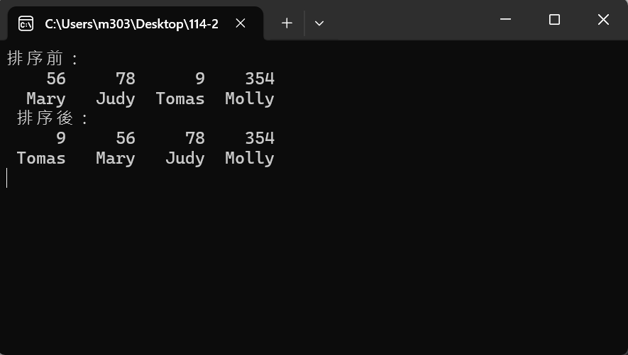
using System;
using System.Collections.Generic;
using System.Linq;
using System.Text;
using System.Threading.Tasks;
using static System.Console;

namespace ConsoleApp1
{
internal class Program
{
static void Main(string[] args)
{
//宣告陣列並初始化元素
int[] number = { 56, 78, 9, 354 };
string[] name = { "Mary", "Judy", "Tomas", "Molly" };
Write("排序前：\n");
//讀取排序前的陣列元素
foreach (int element1 in number)
Write($"{element1,6} ");
WriteLine();
foreach (string element2 in name)
Write($"{element2,6} ");
Array.Sort(number, name);//遞增排序
Write("\n 排序後：\n");
//讀取排序後元素
for (int item1 = 0; item1 < number.Length; item1++)
Write("{0, 6} ", number[item1]);
WriteLine();
for (int item2 = 0; item2 < name.Length; item2++)
Write("{0, 6} ", name[item2]);
WriteLine();
ReadKey();
}
}
}

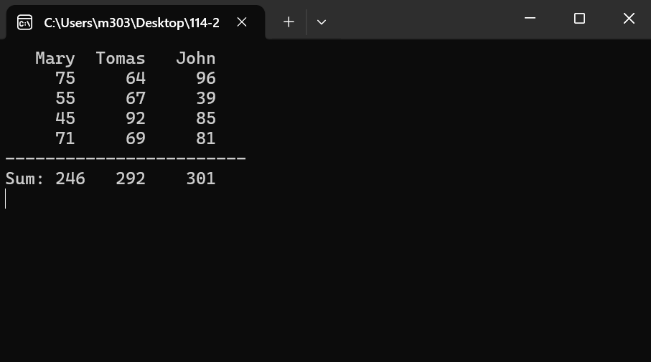
using System;
using System.Collections.Generic;
using System.Linq;
using System.Text;
using System.Threading.Tasks;
using static System.Console;

namespace ConsoleApp2
{
internal class Program
{
static void Main(string[] args)
{
int outer, inner;//巢狀 for 的計數器
int[] sum = new int[3];//存放每個人的總分
string[] name = { "Mary", "Tomas", "John" };
//讀取名字並輸出，{0,7}表示預設 7 個欄位來存放
foreach (string item in name)
Write("{0,7}", item);
WriteLine();
int[,] score = {{75, 64, 96}, {55, 67, 39},{45, 92, 85}, {71, 69, 81} };
//GetLength()方法取得第 1、2 維陣列
int row = score.GetLength(0);
int column = score.GetLength(1);
//讀取列數
for (outer = 0; outer < row; outer++)
{
//讀取欄的元素
for (inner = 0; inner < column; inner++)
Write($"{score[outer, inner],7}");
WriteLine();
sum[0] += score[outer, 0];//第 1 欄分數相加
sum[1] += score[outer, 1];//第 2 欄分數相加
sum[2] += score[outer, 2];//第 3 欄分數相加
}
WriteLine("------------------------");
WriteLine($"Sum: {sum[0]} {sum[1],5} {sum[2],6}");
ReadKey();
}
}
}
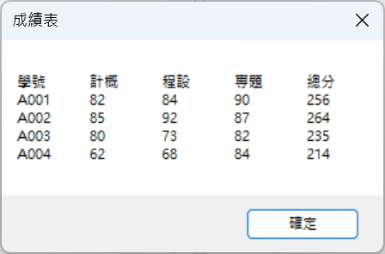
using System;
using System.Collections.Generic;
using System.ComponentModel;
using System.Data;
using System.Drawing;
using System.Linq;
using System.Text;
using System.Threading.Tasks;
using System.Windows.Forms;

namespace WindowsFormsApp1
{
public partial class Form1 : Form
{
public Form1()
{
InitializeComponent();
}

private void Form1_Load(object sender, EventArgs e)
{
string[] stu = new string[] { "A001", "A002", "A003", "A004" }; //存放學生學號
string[] sub = new string[] { "計概", "程設", "專題" }; //存放科目名稱
int[,] score = new int[,] { { 82, 84, 90 }, { 85, 92, 87 }, { 80, 73, 82 }, { 62, 68, 84 } };
int[] sum = new int[4] { 0, 0, 0, 0 };
for (int y = 0; y <= score.GetUpperBound(0); y++)
{
for (int x = 0; x <= score.GetUpperBound(1); x++)
sum[y] += score[y, x];
}
string msg = "學號\t";
foreach (string s in sub)
msg += s + "\t";
msg += "總分\n";
for (int y = 0; y <= stu.GetUpperBound(0); y++)
{
msg += stu[y] + "\t";
for (int x = 0; x <= sub.GetUpperBound(0); x++)
msg += $"{score[y, x]}\t";
msg += $"{sum[y]}\n";
}
MessageBox.Show(msg, "成績表");
Application.Exit();
}
}
}

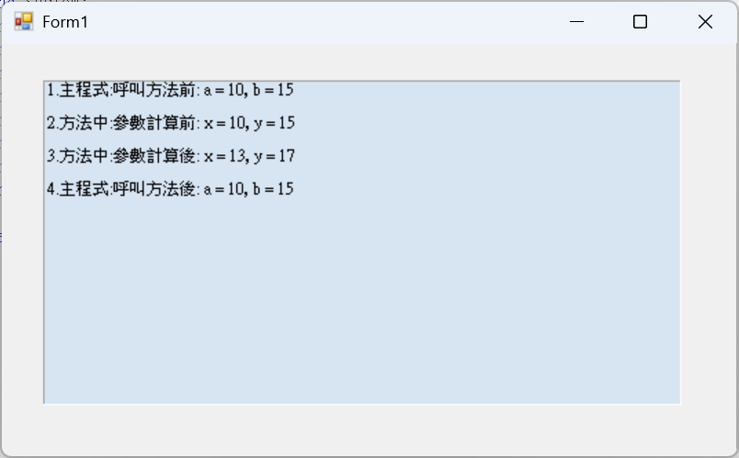
using System;
using System.Collections.Generic;
using System.ComponentModel;
using System.Data;
using System.Drawing;
using System.Linq;
using System.Text;
using System.Threading.Tasks;
using System.Windows.Forms;

namespace WindowsFormsApp2
{
public partial class Form1 : Form
{
public Form1()
{
InitializeComponent();
}

//以傳值方式呼叫 PassValue 方法
private void PassValue(int x, int y)
{
LblMsg.Text += $"2.方法中:參數計算前: x = {x}, y = {y}\n\n";
x += 3; //參數 x 加 3
y += 2; //參數 y 加 2
LblMsg.Text += $"3.方法中:參數計算後: x = {x}, y = {y}\n\n";
}

private void Form1_Load(object sender, EventArgs e)
{
int a = 10, b = 15;
LblMsg.Text = $"1.主程式:呼叫方法前: a = {a}, b = {b}\n\n";
PassValue(a, b);
LblMsg.Text += $"4.主程式:呼叫方法後: a = {a}, b = {b}\n\n";
}

private void LblMsg_Click(object sender, EventArgs e)
{

}
}
}

